

**UNIVERSITY OF PETROLEUM & ENERGY STUDIES**

**Dehradun**

# Docker

**Experiment**

**Name: Harshil Bhardwaj**

**Course: B. TECH CSE DevOps (2018-22)**

**Roll no.: R171218045**

**Sapid: 500068580**

**Experiment- 4**

Create a Dockerfile

$ touch Dockerfile

Open Dockerfile and type

FROM ubuntu

RUN apt-get update

ENV DEBIAN_FRONTEND noninteractive

RUN apt-get install nginx -y

RUN echo "daemon off;" >> /etc/nginx/nginx.conf

COPY index.html /var/www/html/

EXPOSE 80

CMD ["nginx"]

Create a index.html file and type

$ touch index.html

<html>

<h1>Level Up In Tech</h1>

<p> Learning it. Labbing it. Leveling Up</p>

<p>This is a simple static website, built and deliver from a docker container</p>

<p>Visit us here: <a href="levelupintech.com">Level Up In Tech</a></p>

</html>

Now run command

$ docker build –t nginx:1.0 .

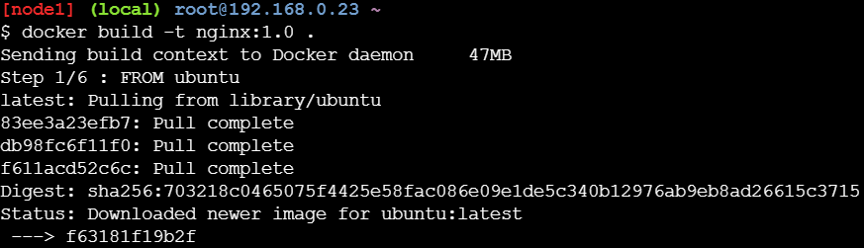

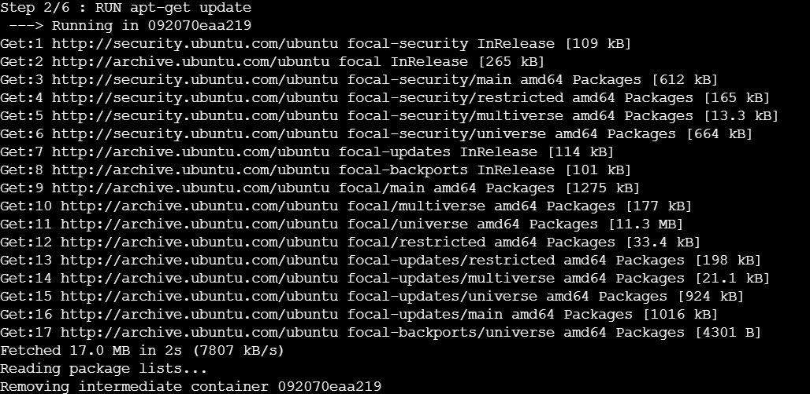

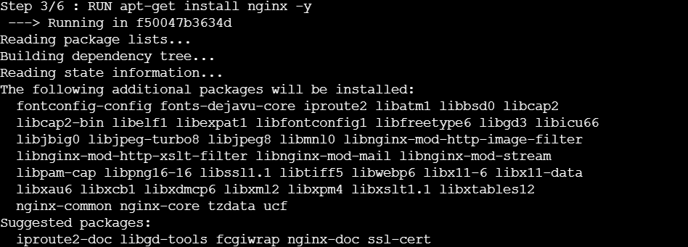

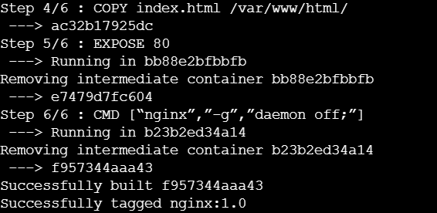

To check images

$ docker images

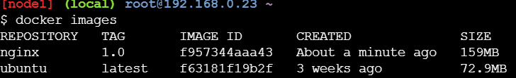

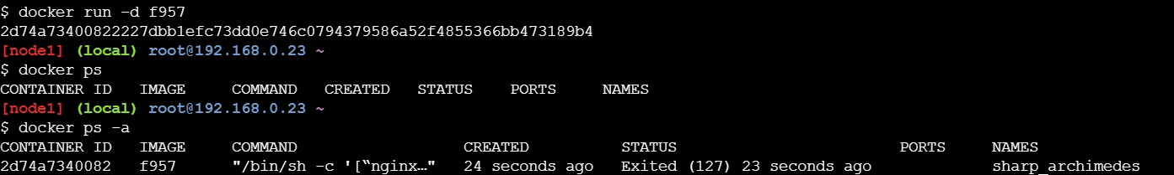

Login to docker

$ docker login

(Enter your username and passsword)

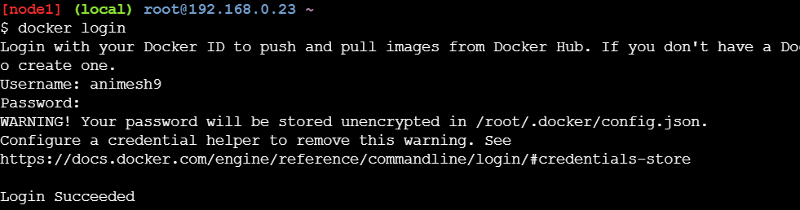

Change tag name and version

$ docker tag f957 animesh9/ngnixtag

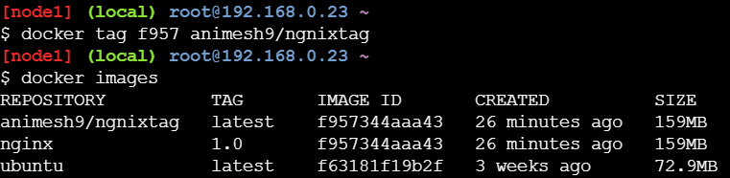

Push to docker repository

$ docker push animesh9/ngnixtag

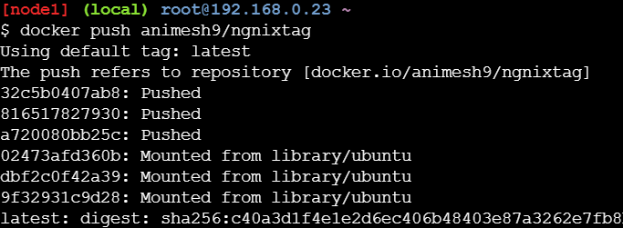

Check dockerhub you will find a new repository as ngnixtag and your image in it.

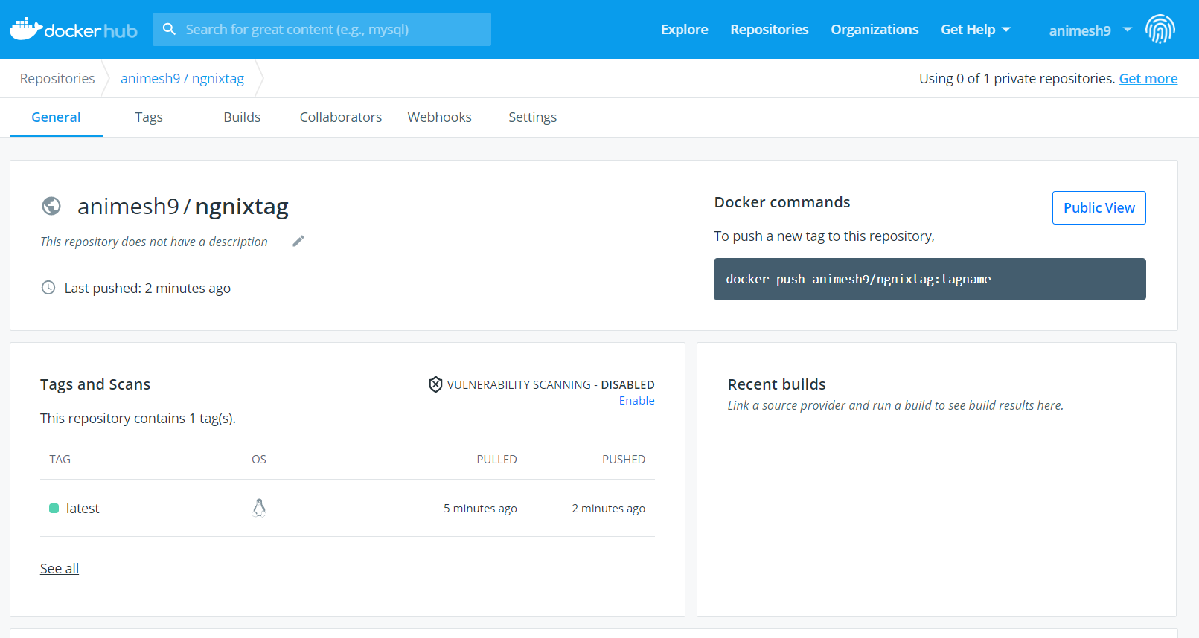

To pull this repository to your local machine

$ docker pull animesh9/ngnixtag:latest

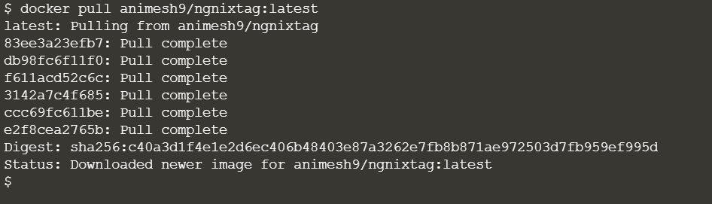

Running a container

$ docker run –d –p 5000:80 animesh9/ngnixtag:latest

